Name  Naming and Structure for Organic Molecules | Expanded Structure | Compressed Structure
 | 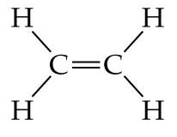
 | 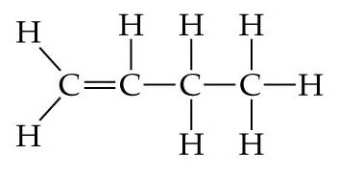
 | 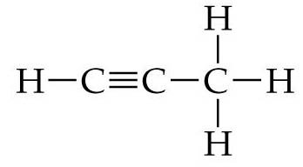
 | 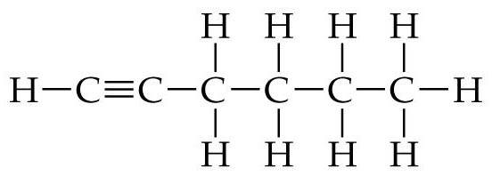
 |  | 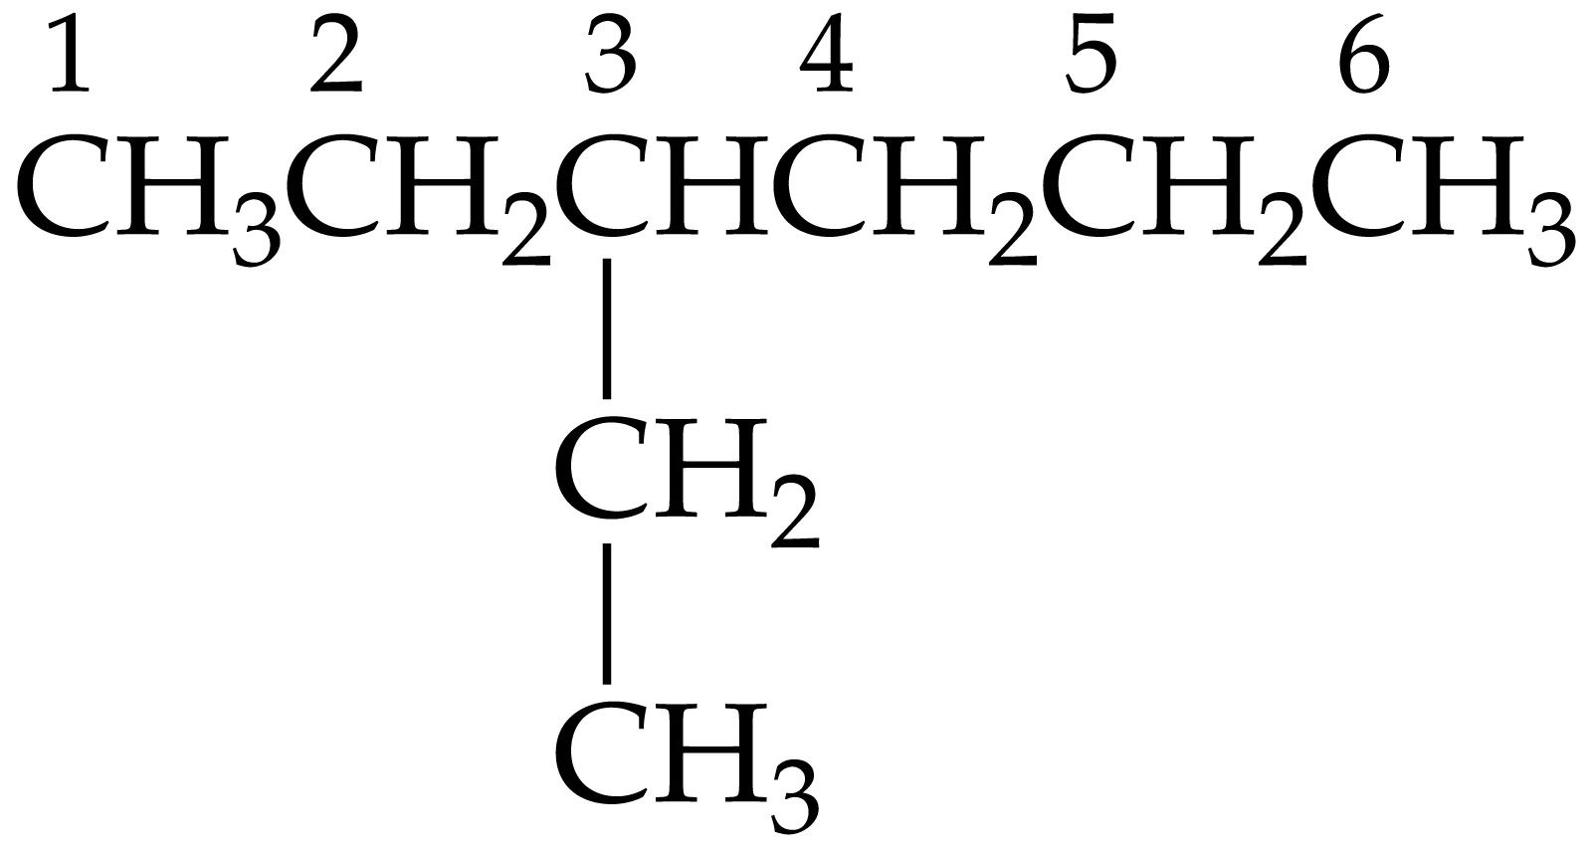
 |  | 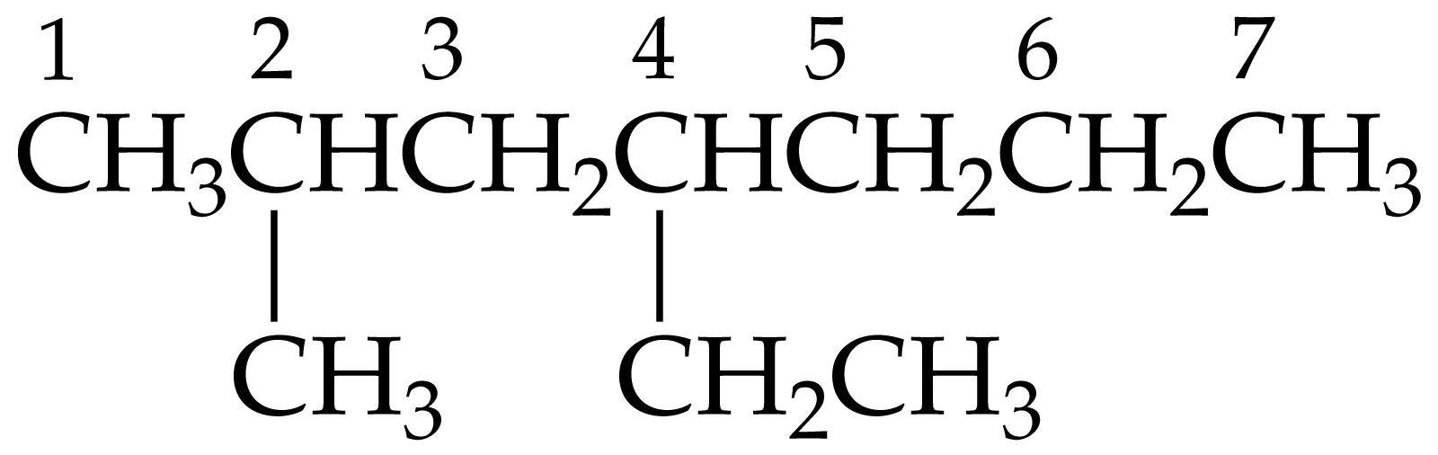
3,4-dimethyl-3-hexene |  | 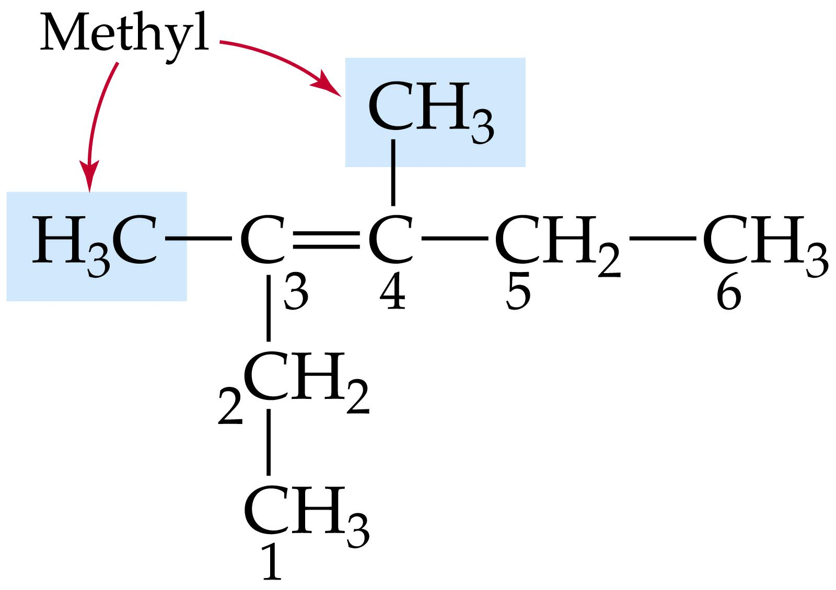

Naming Alkenes 1

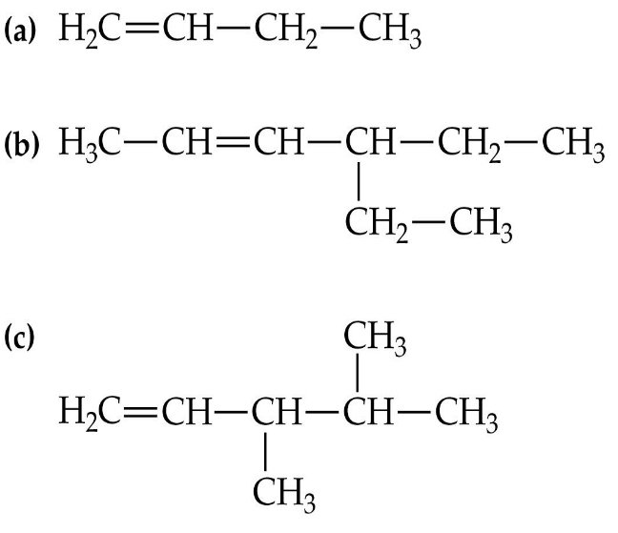 | Name | Expanded Formula
a

b
c

Naming Alkenes 2

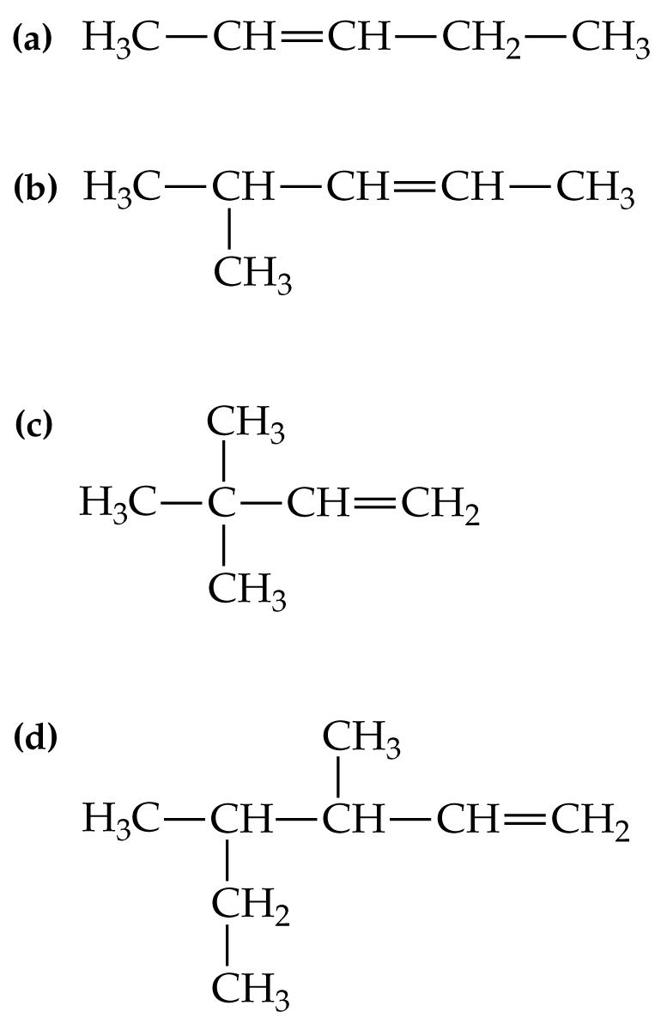
 | Name | Expanded Formula
a

b
c
d

Naming Alkynes 1

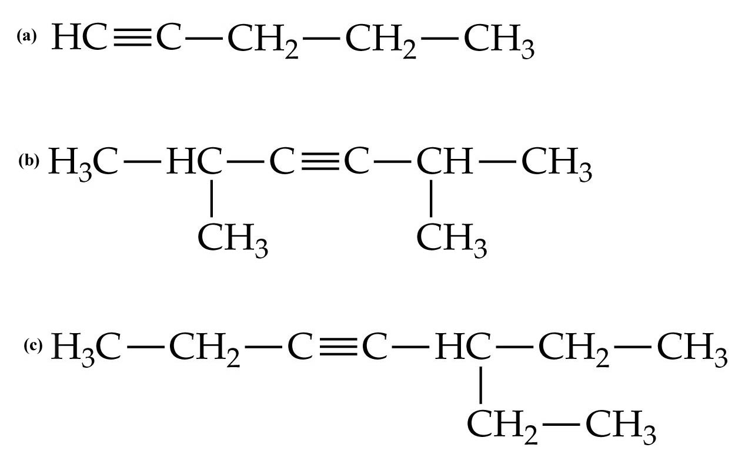 | Name | Expanded Formula
a

b
c

Naming Alkynes 2

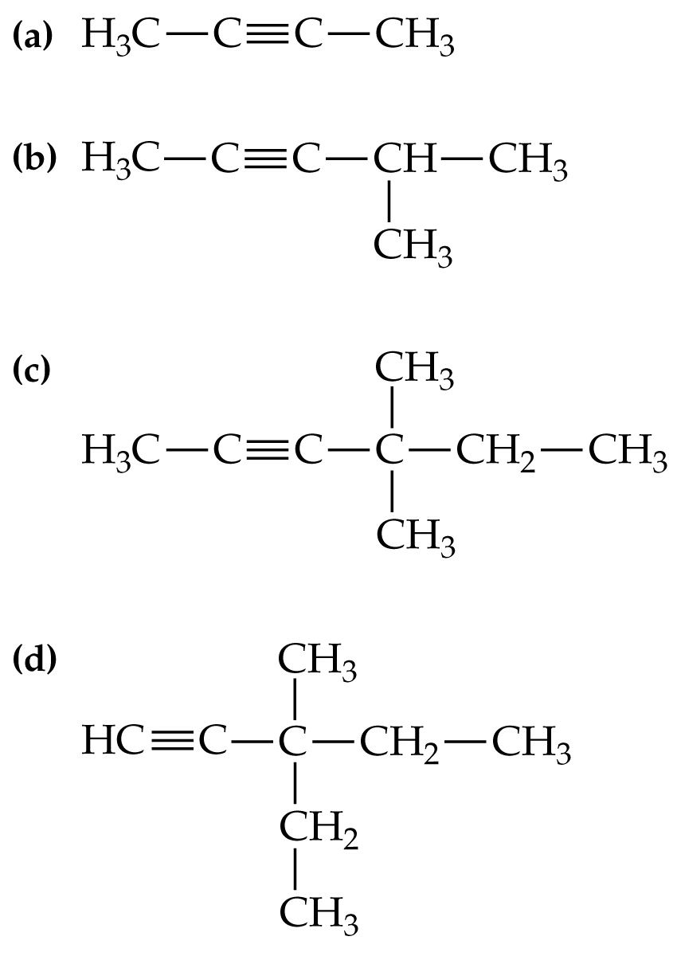
 | Name | Expanded Formula
a

b
c
d

Cyclic Compounds

A cyclic compound has the carbon chain formed into a ring.

The prefix "cyclo-" is added to the name.
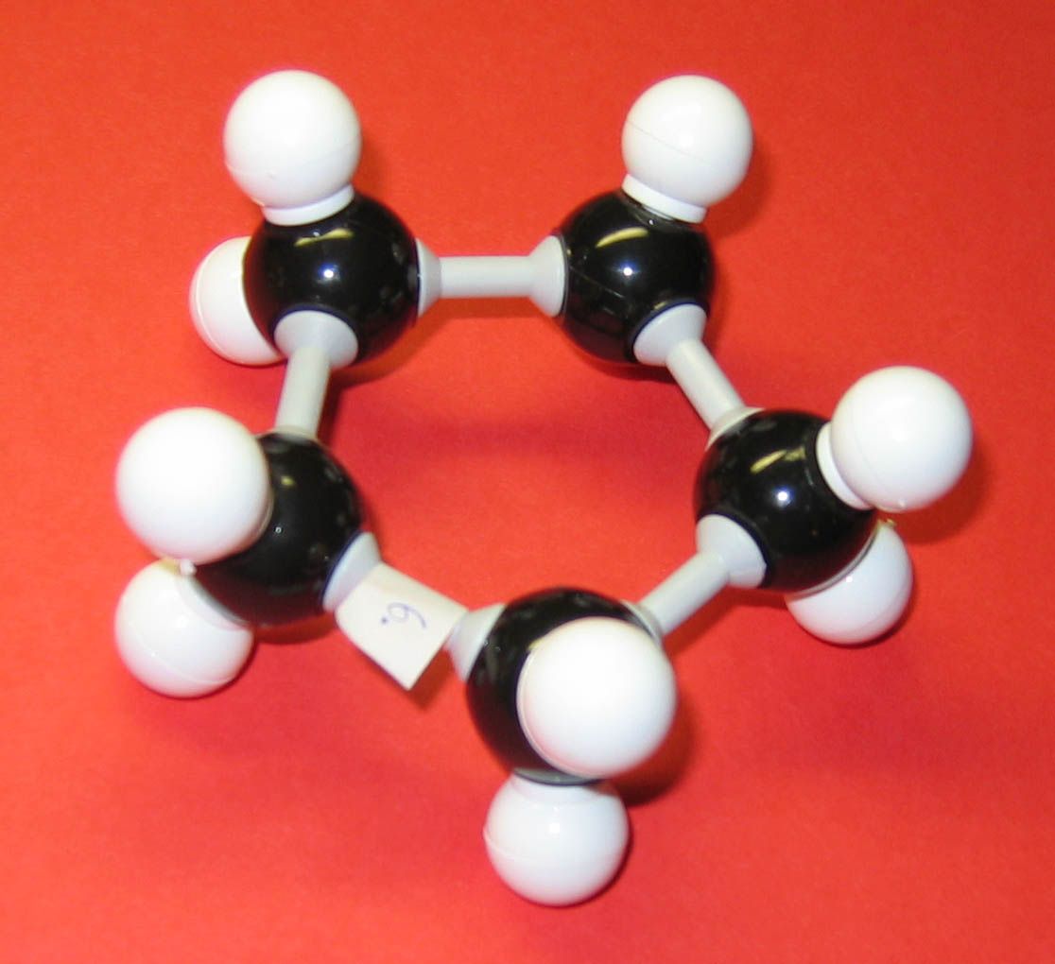
There are 5 carbons in cyclic formation.

This molecule is a model of cyclopentane.

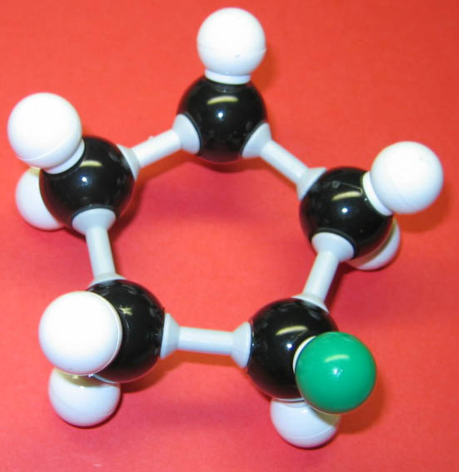
If we add on a chlorine

The molecule will become ______________

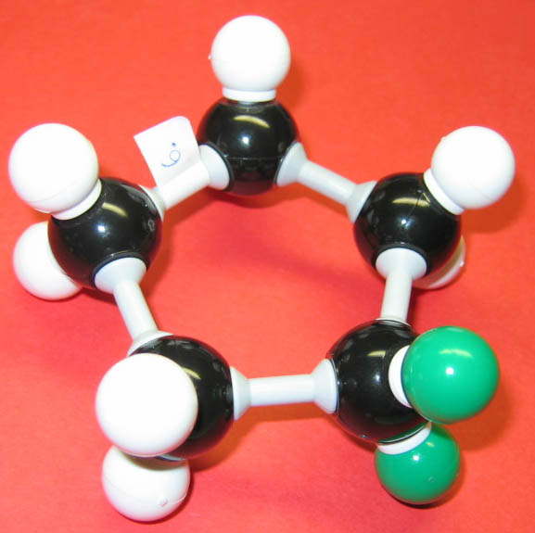

__________________

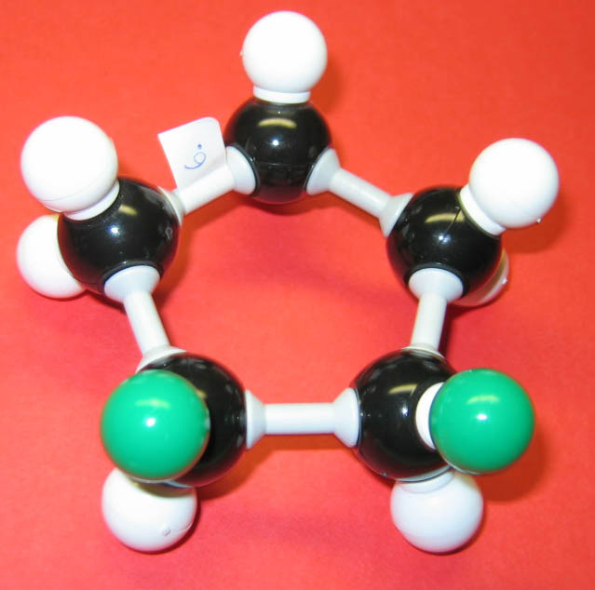

__________________

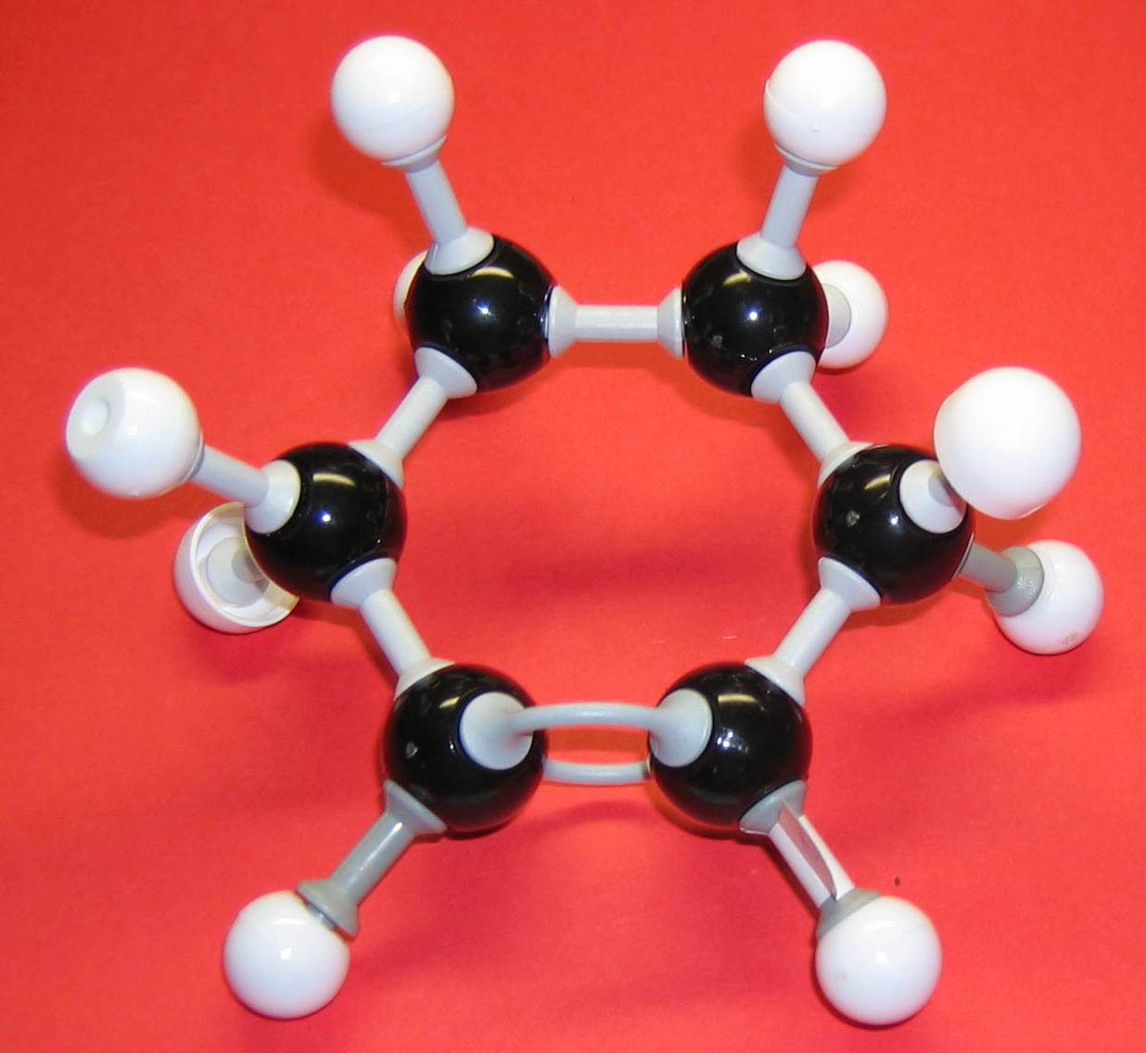

This molecule has 6 carbons in cyclic formation, plus a double bond.

___________________

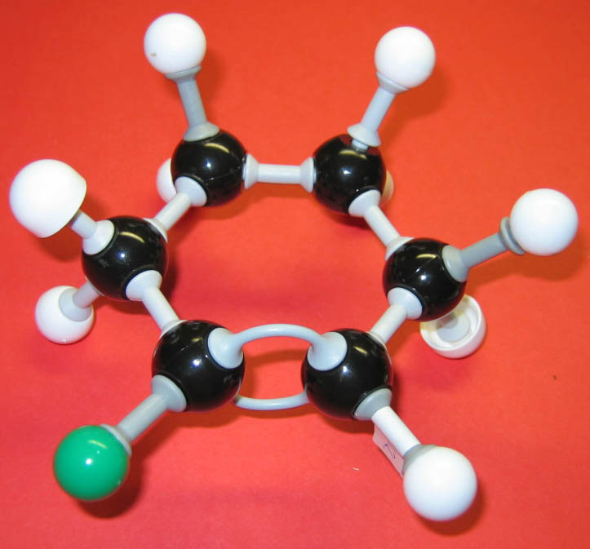

___________________

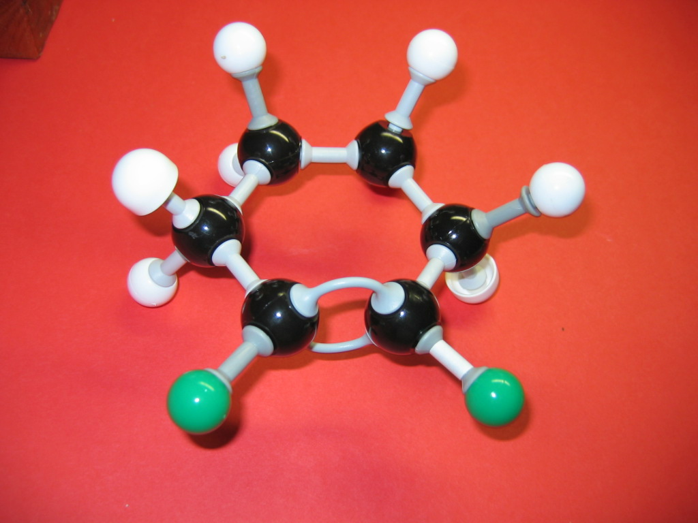

___________________

Naming and Structure for Organic Molecules –ANSWERS

Name | Expanded Structure | Compressed Structure
ethene |  | CH₂CH₂
butene |  | CH₂CHCH₂CH₃
propyne |  | CHCCH₃
hexyne |  | CHCCH₂CH₂CH₂CH₃  or  CHC(CH₂)₃CH₃
3-ethylhexane | 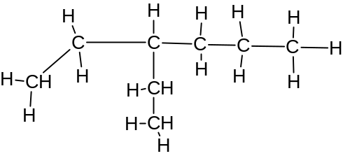
2-methyl-4-ethylheptane | 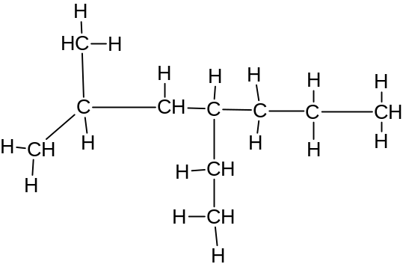
3,4-dimethyl-3-hexene | 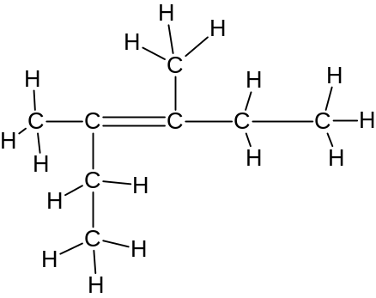

Naming Alkenes 1- ANSWERS
 | Name | Expanded Formula
a | butene | 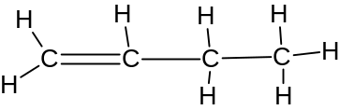
b | 4-ethyl-2-hexene | 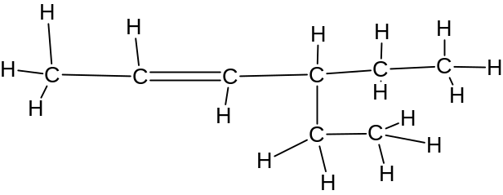
c | 3,4-dimethylpentene | 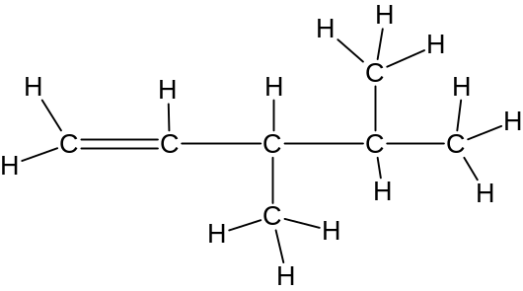

Naming Alkenes 2- ANSWERS

 | Name | Expanded Formula
a | 2-pentene  note this has cis/trans option | 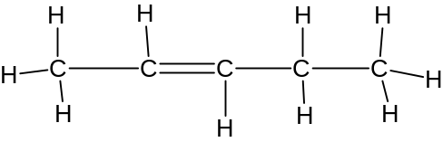
b | 4-methyl-2-pentene | 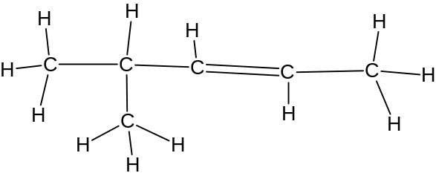
c | 3,3-dimethylbutene | 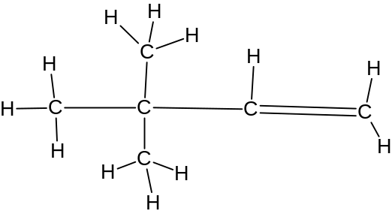
d | 3,4-dimethyl hexene | 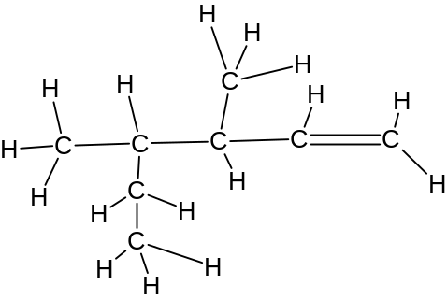

Naming Alkynes 1- ANSWERS

 | Name | Expanded Formula
a | pentyne | 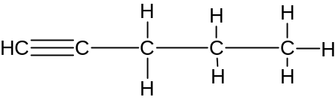
b | 2,5-dimethyl-3-hexyne | 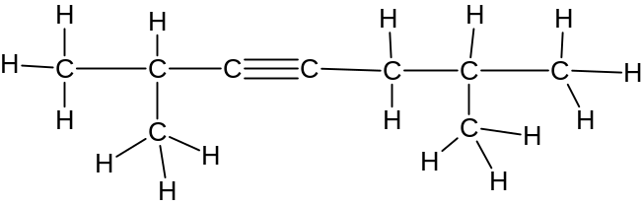
c | 5-ethyl-3-heptyne | 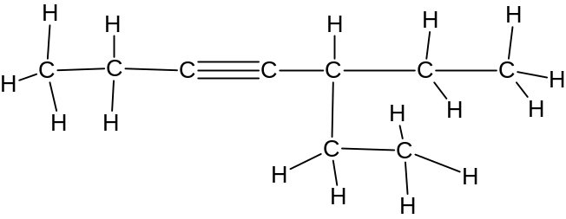
Naming Alkynes 2-ANSWERS

 | Name | Expanded Formula
a | 2-butyne | 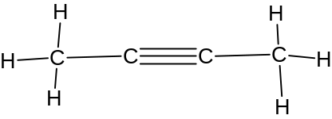
b | 4-methyl-2-pentyne | 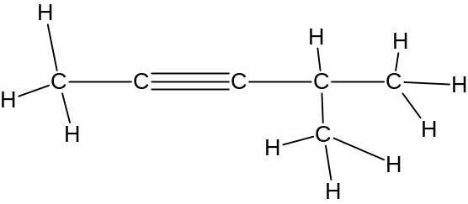
c | 4,4-dimethyl-2-hexyne | 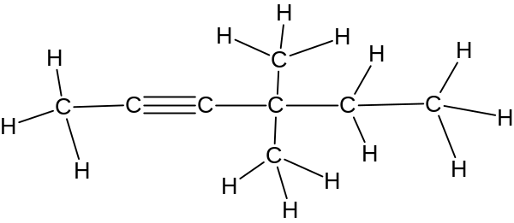
d | 3-methyl-3-ethylpentyne | 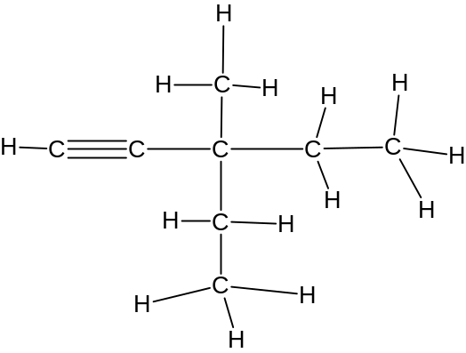

Cyclic Compounds- ANSWERS

A cyclic compound has the carbon chain formed into a ring.

The prefix "cyclo-" is added to the name.
There are 5 carbons in cyclic formation.

This molecule is a model of cyclopentane.

If we add on a chlorine

The molecule will become chlorocyclopentane

1,1-dichlorocyclopentane

1,2-dichlorocyclopentane

This molecule has 6 carbons in cyclic formation, plus a double bond.

cyclohexene

chlorocyclohexene

1,2 -dichlorocyclohexene

